Names: __________________________

Exam Review

1. For each plot type, list the number and type of variables that can be represented by the plot (for example, pie chart: 1 categorical variable).
   1. Dot plot:
   2. Bar chart:
   3. Histogram:
   4. Side-by-side bar chart, stacked bar chart, standardized bar chart:
   5. Scatterplot:
   6. Box plot:
2. Based on this side-by-side bar chart, answer the following questions.

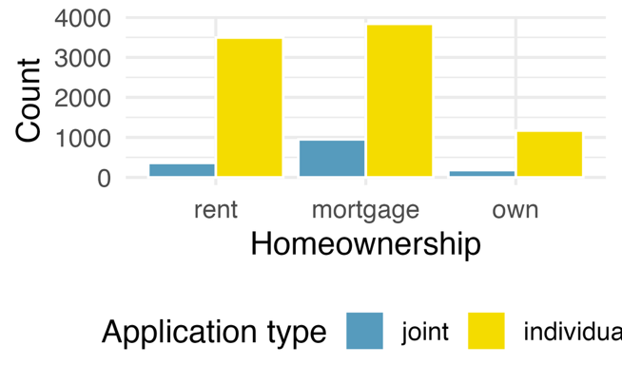

* 1. What does this chart tell you about the number of total loan applications for each type of home ownership?
  2. What does this chart tell you about the number of individual loan applications compared to the number of joint loan applications for each type of home ownership?

1. This contingency table shows the genders and species of animals at a local shelter. Use it to answer the following questions.

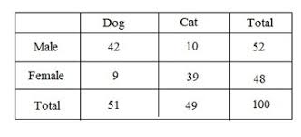

* 1. What proportion of dogs at this shelter are female?
  2. What proportion of female animals are dogs?
  3. What proportion of cats are males?
  4. What proportion of male animals are cats?
  5. Sketch a bar chart that shows the total number of dogs compared to the total number of cats.
  6. Sketch a stacked bar chart that shows the total number of dogs compared to the total number of cats, broken down by gender.

1. Sketch distributions with each of the following characteristics.

Right-skewed Symmetrical Left-skewed

|  |  |
| --- | --- |
| Student Age | Exam Score (out of 20) |
| 12 | 12 |
| 6 | 3 |
| 18 | 20 |
| 15 | 18 |
| 9 | 6 |

1. In this experiment, students of different ages were given the same exam, and their scores were recorded. A sample of 5 students is shown in the table below.
   1. What type of plot would be best for visualizing this data?
   2. Sketch the appropriate visualization below using only the 5 data points shown above.
2. The histogram below shows the distribution of visitors at a theme park on a single day. Use this histogram to answer the following questions.

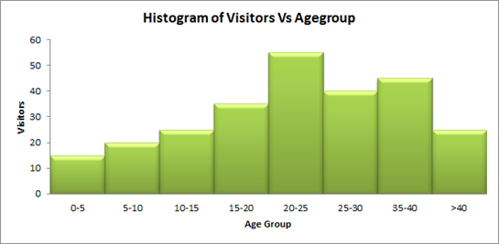

* 1. How would you describe the distribution?
  2. In this sample, for ages 25 and under, what happens to the number of visitors as age increases?
  3. Which bin most likely contains the mean visitor age in this sample?